PROJECT WORK

**PROJECT TITLE:** Competitive Analysis of Leading Travel Aggregators

**MENTOR:** Sashi Kanth Beta

**TEAM ID:**  LTVIP2023TMID08036

**TEAM SIZE:** 4

**TEAM LEADER:** Rachakonda Gayatri Swathi

**TEAM MEMBERS:** Kondapu Takshayani

Padala Yogitha

Kuppa Meghana

[Year]

* **Data Analytics**

Data analytics is a multidisciplinary field that employs a wide range of analysis techniques, including math, statistics, and computer science, to draw insights from data sets. Data analytics is a broad term that includes everything from simply analysing data to theorizing ways of collecting data and creating the frameworks needed to store it.

* **Data Analyst?**

Data analyst is a broad term for someone paid to analyse data and create insights that viewers can act on. Skilled data analysts are some of the most sought-after professionals in the world. Because demand is strong and the supply of people who can do this job well is limited, data analysts command higher-than-average salaries and perks, even at the entry level. Data analyst jobs can be found throughout a diverse mix of companies and industries. Some top jobs in data analysis involve using data to make investment decisions, target customers, assess risks, or decide on capital allocations.

* **Introduction**

Competitive analysis of leading travel aggregators involves evaluating key players in the travel industry, examining their strengths and weaknesses, market share, pricing strategies, user experience, and technological innovations. By comparing factors such as customer reviews, features, and booking options, you can gain insights into how these aggregators differentiate themselves and stay ahead in the market.

* **Market Players**

The role of the data analyst has become increasingly important since the early 2000s, with employment opportunities in industries ranging from finance to marketing to social media. In addition to knowing your way around computers, data analysts must also be well-versed in statistical methods and models. Big data and machine learning are among the cutting-edge applications of data analysis.

* **Overview of Travel Aggregators and Their Significance**

A travel aggregator is a website or platform that allows users to search and compare prices for travel-related products and services, such as flights, hotels, vacation rentals, and car rentals, from multiple providers. Travel aggregators typically provide a simple and convenient way for users to find and book travel products and services, and often offer additional features such as reviews, ratings, and photos to help users make informed decisions. Some popular examples of travel aggregator websites include Expedia, Booking.com, Kayak, and Trivago.

Travel aggregators typically generate revenue by charging commissions or fees to the travel providers whose products and services are featured on their platform. Some also earn revenue through advertising, or by offering additional services such as travel insurance or car rental.

* **Tourism Analysis for Business**

The business requirements for tourism analysis often include gathering and analyzing data related to traveler preferences, trends, demographics, and economic impact. This helps businesses make informed decisions about marketing strategies, resource allocation, and customer experiences to enhance their competitiveness in the tourism industry. It involves using tools such as data analytics, market research, and customer feedback to tailor services and offerings to meet the needs and expectations of travelers.

* **Literature Survey**

A literature survey of competitive analysis of leading travel aggregators would involve reviewing existing academic research, industry reports, and publications that examine the competitive strategies and dynamics among major players in the travel aggregation space. Researchers and analysts often study factors such as market share, customer preferences, pricing strategies, user experience, technological innovations, and business models adopted by companies like Expedia, Booking Holdings, and others.

* **Project Flow**
* Define Problem / Problem Understanding
* Specify the business problem
* Business requirement
* Literature Survey
* Social or Business Impact
* Data Collection & Extraction from Database
* Collect the dataset
* Connect IBM DB2 with IBM cognos
* Data Preparation
* Prepare the Data for Visualization
* Data Visualizations
* No of Unique Visualizations
* Dashboard
* Responsive and Design of Dashboard
* Story
* No of Scenes of Story
* Report
* Creating a report
* Performance Testing
* Amount of Data Rendered to DB ‘
* Utilization of Data Filters
* No of Calculation Fields
* No of Visualizations/ Graphs
* Web Integration
* Dashboard and Story embed with UI With Flask
* Project Demonstration & Documentation
* Record explanation Video for project end to end solution
* Project Documentation-Step by step project development procedure

* **Data Collection & Extraction From Database:**

Data Collection & Extraction From Database: Data collection is the process of gathering and measuring information on variables of interest, in an established systematic fashion that enables one to answer stated research questions, test hypotheses, and evaluate outcomes and generate insights from the data.

* **Data Preparing:**

Preparing the data for visualization involves cleaning the data to remove irrelevant or missing data, transforming the data into a format that can be easily visualized, exploring the data to identify patterns and trends, filtering the data to focus on specific subsets of data, preparing the data for visualization software, and ensuring the data is accurate and complete. This process helps to make the data easily understandable and ready for creating visualizations to gain insights into the performance and efficiency.

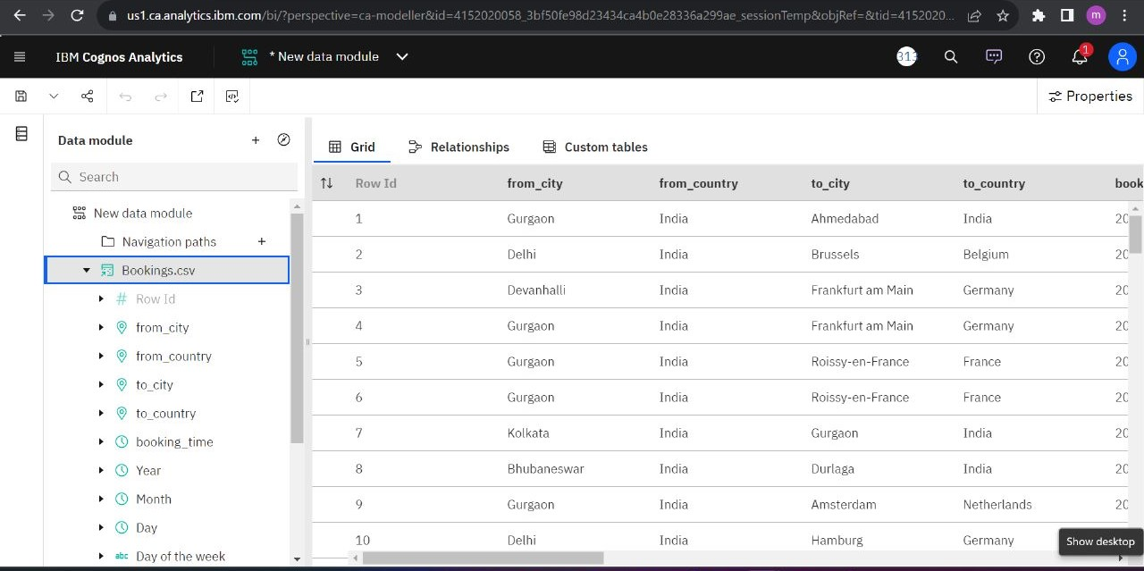

* **Data Visualization:  
  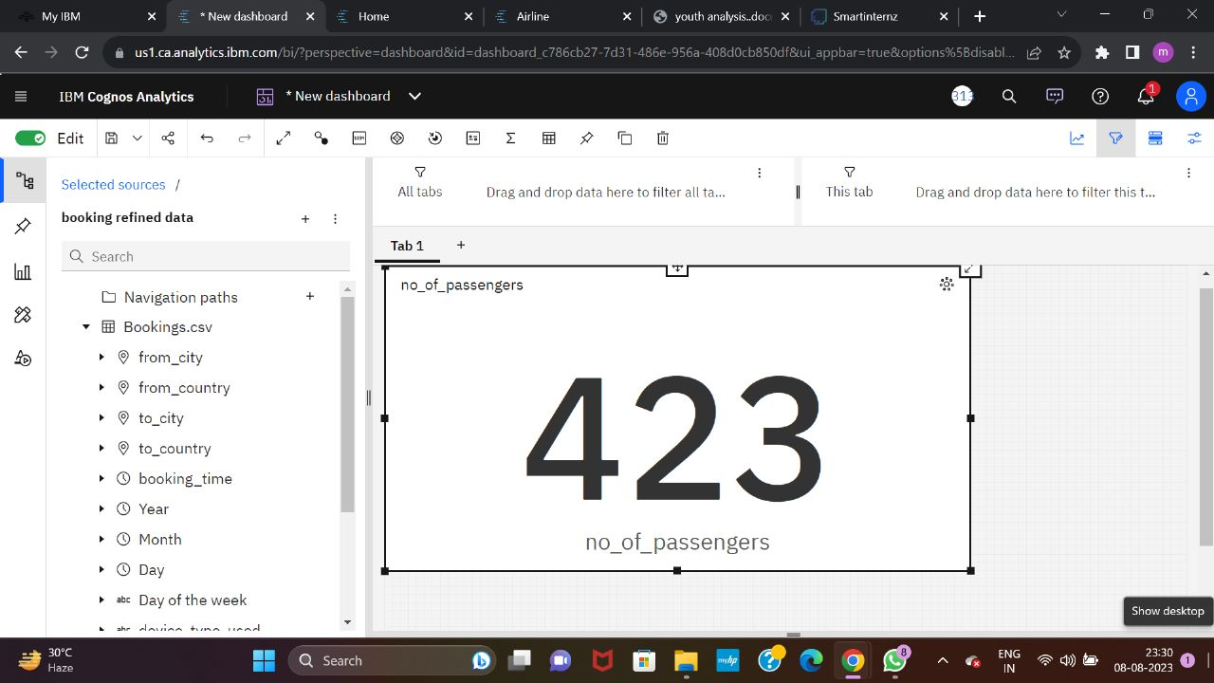**

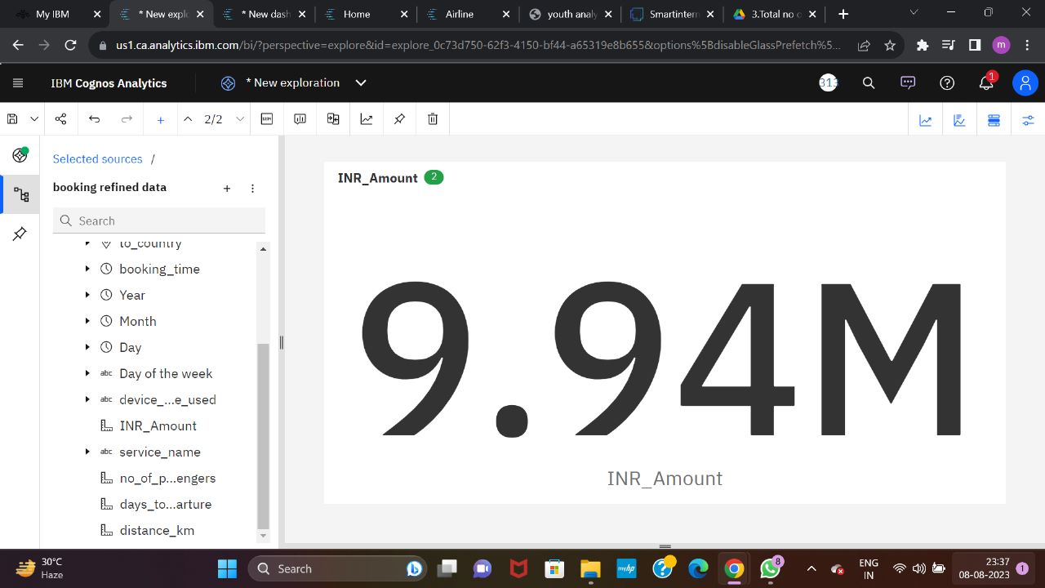

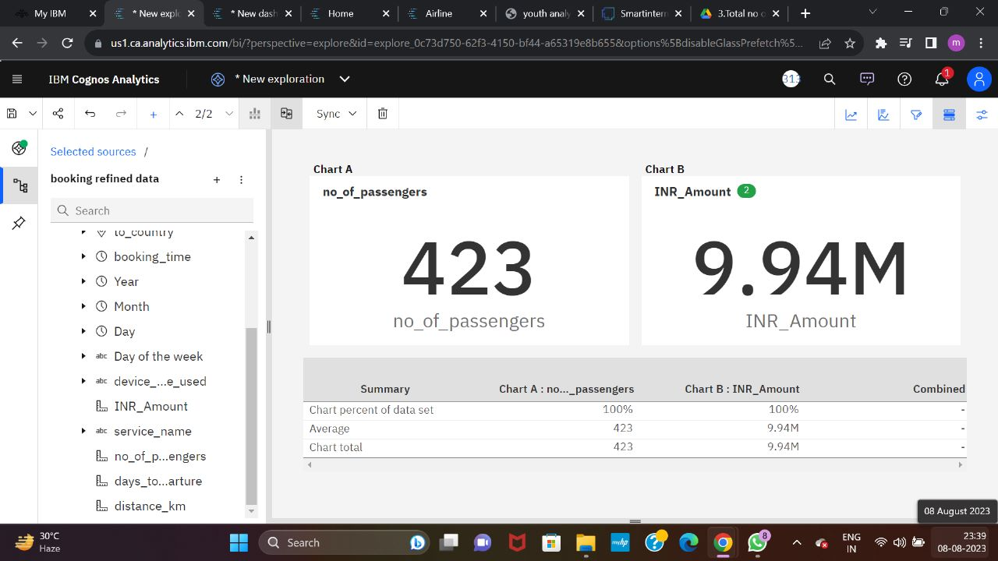

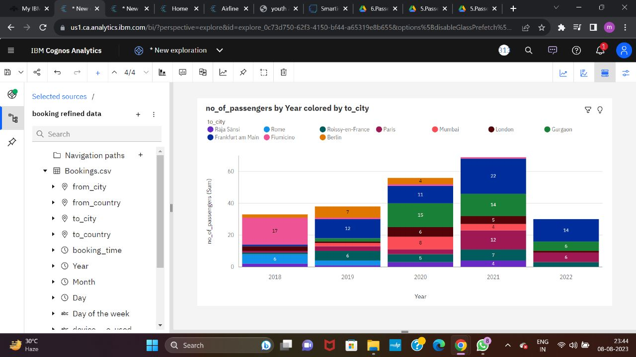

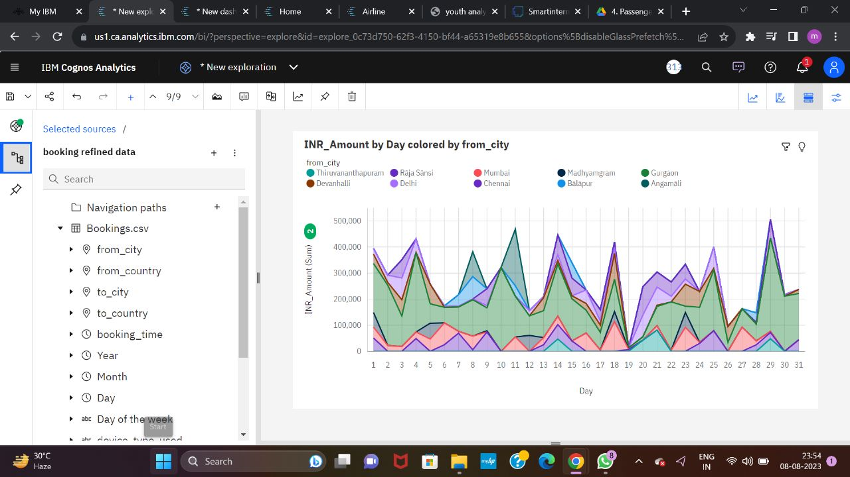

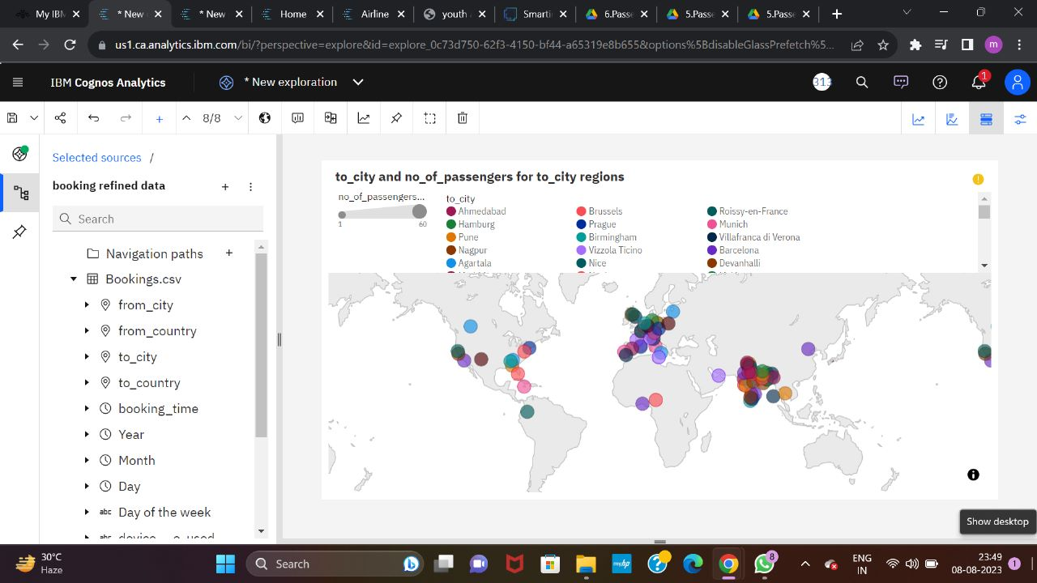

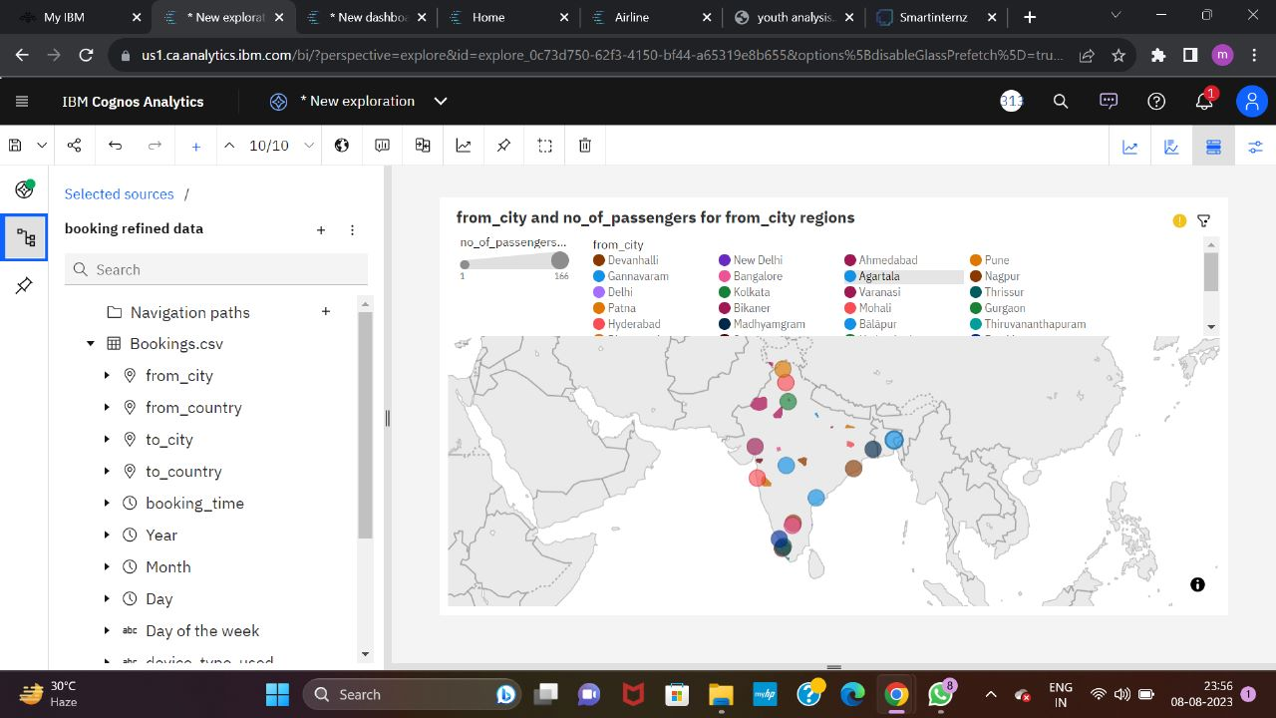

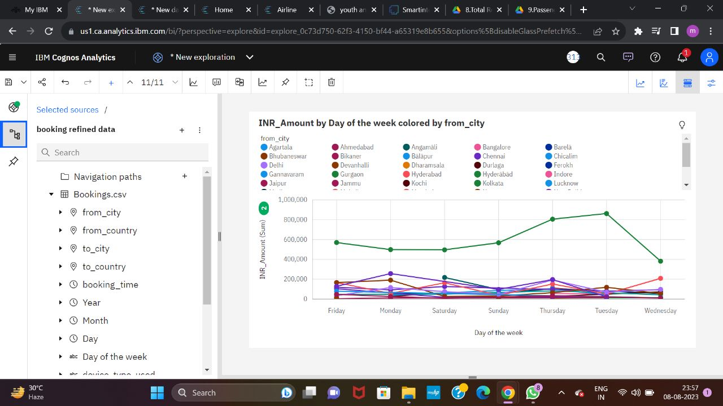

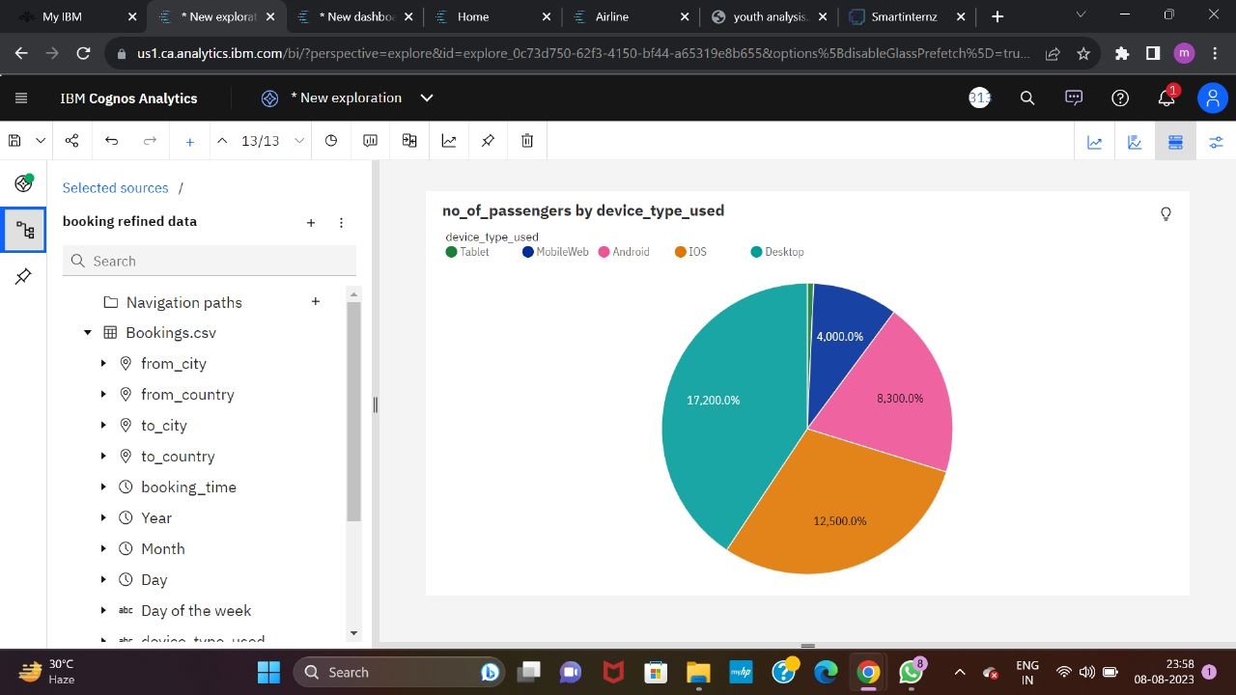

* **Dashboard**

A dashboard is a graphical user interface (GUI) that displays information and data in an organized, easy-to-read format. Dashboards are often used to provide real-time monitoring and analysis of data, and are typically designed for a specific purpose or use case. Dashboards can be used in a variety of settings, such as business, finance, manufacturing, healthcare, and many other industries. They can be used to track key performance indicators (KPIs), monitor performance metrics, and display data in the form of charts, graphs, and tables.

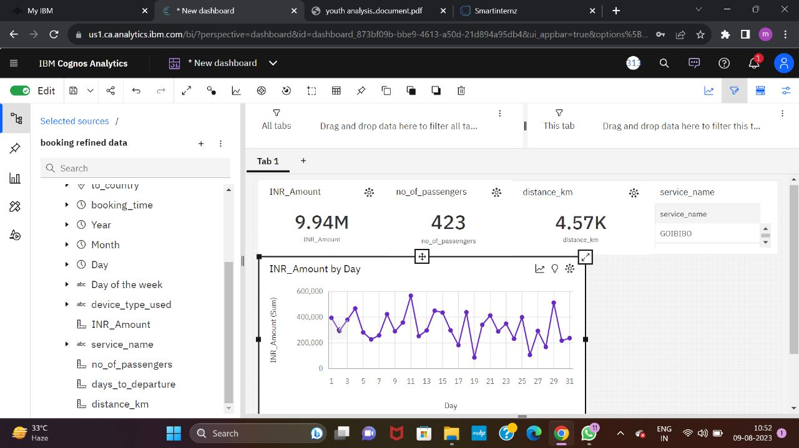

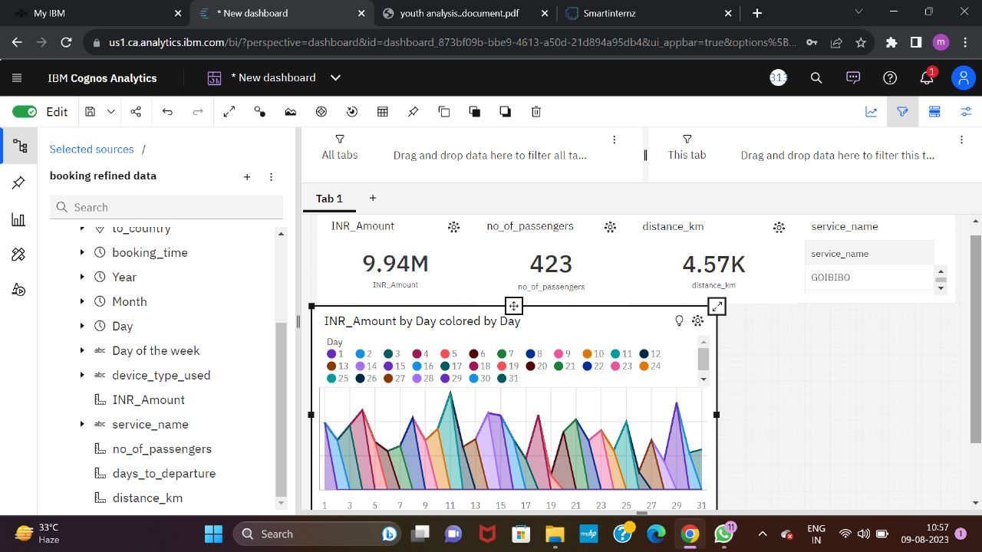

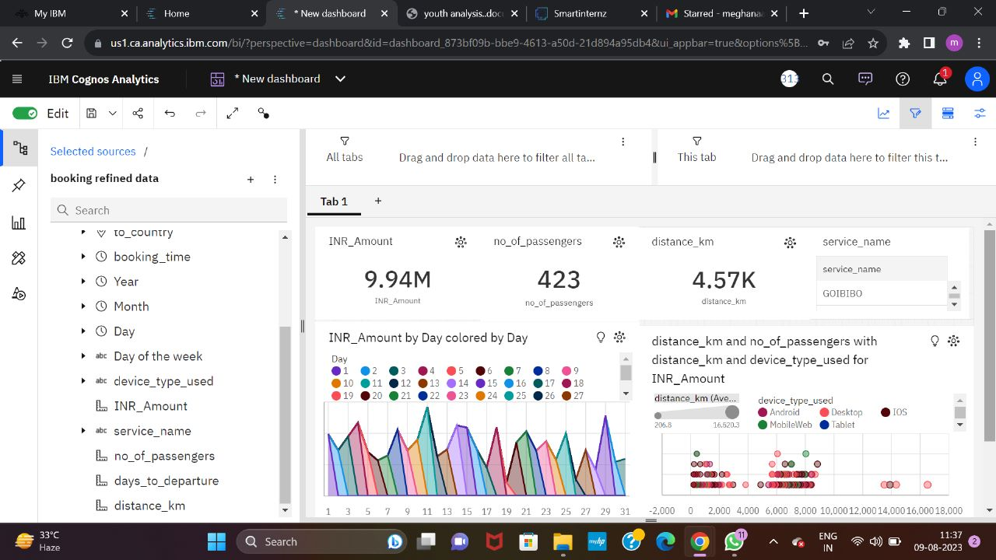

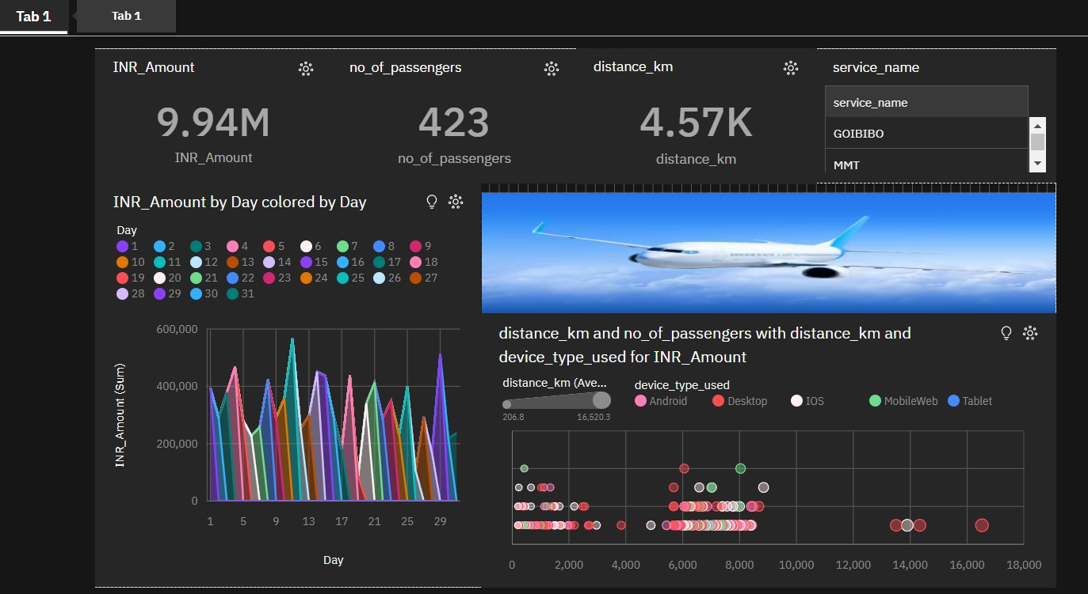

* **Story**

A data story is a way of presenting data and analysis in a narrative format, with the goal of making the information more engaging and easier to understand. A data story typically includes a clear introduction that sets the stage and explains the context for the data, a body that presents the data and analysis in a logical and systematic way, and a conclusion that summarizes the key findings and highlights their implications. Data stories can be told using a variety of mediums, such as reports, presentations, interactive visualizations, and videos.

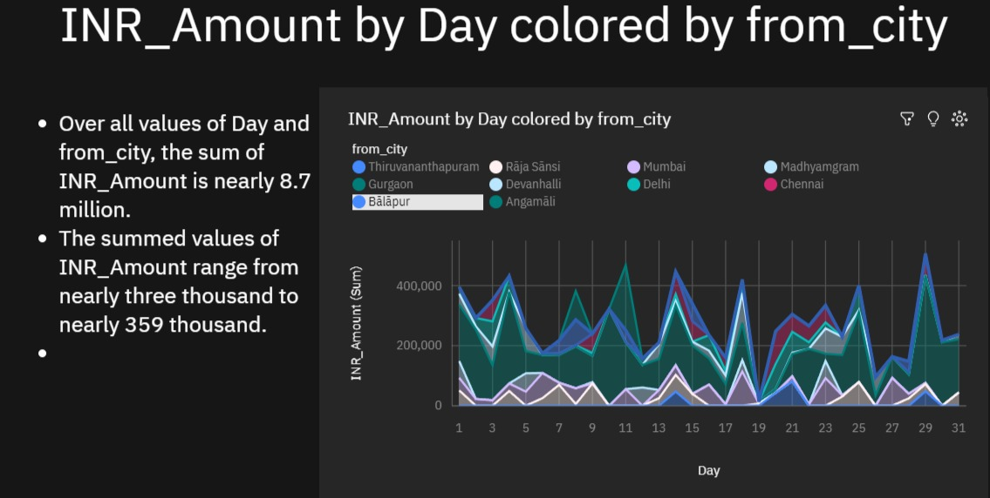

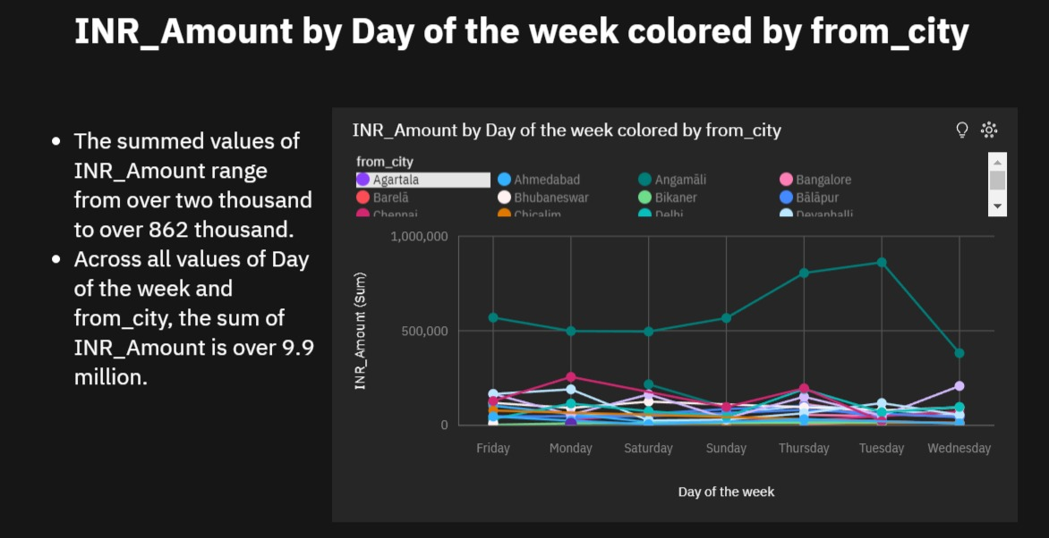

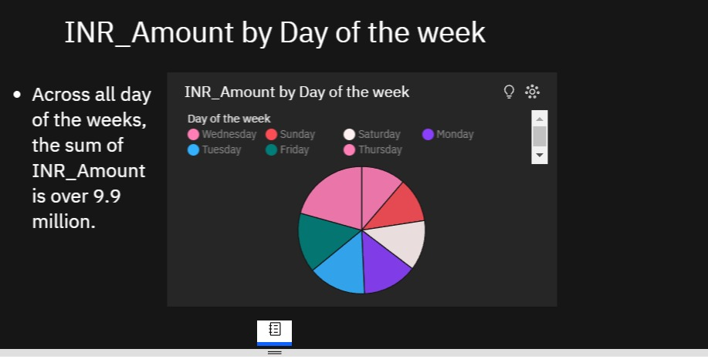

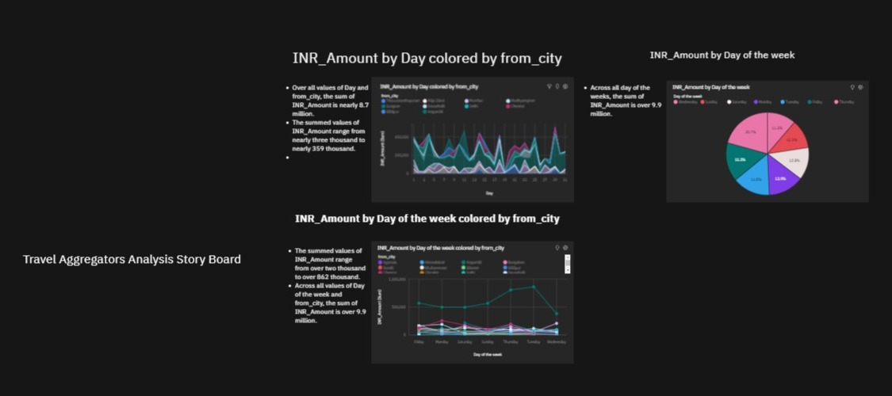

* **Report**

A report is a document that presents information in a specific format and layout, usually based on data from a database or other data source. A report in IBM Cognos can contain various elements, such as tables, charts, graphs, and images, as well as text and data elements, and it is designed to be used by business users to help them better understand their data and make informed decisions. There are several different types of reports available in IBM Cognos, including list reports, crosstab reports, chart reports, and report studio reports, among others. The type of report that you choose will depend on the specific needs and requirements of your organization, as well as the data that you need to present.

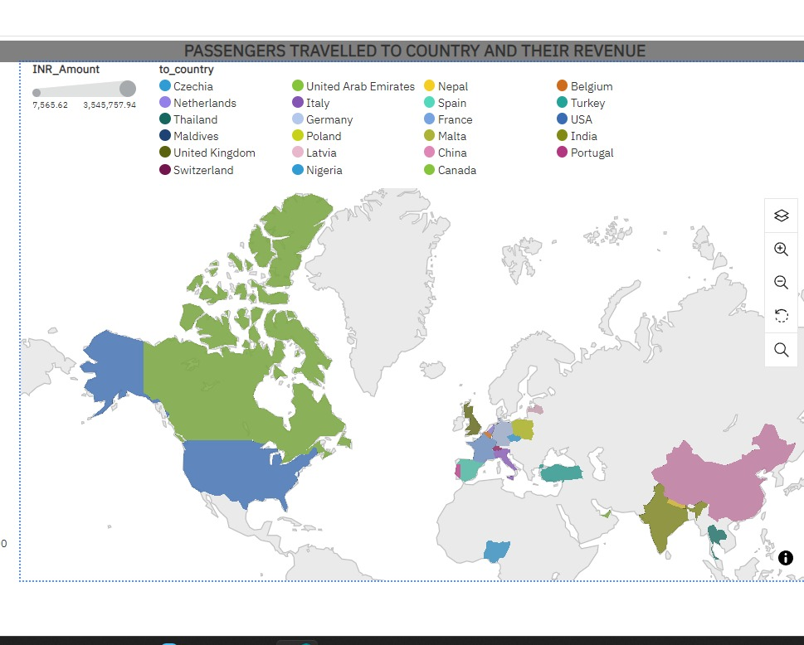

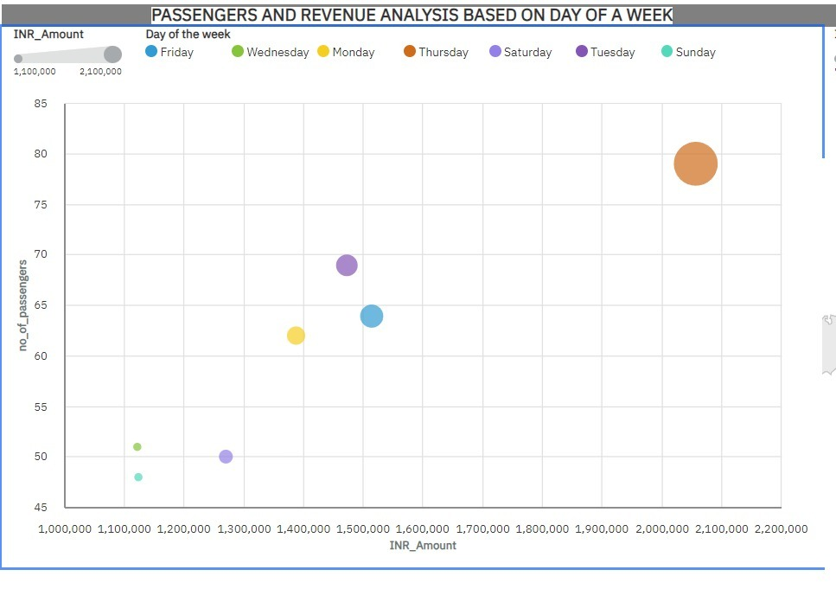

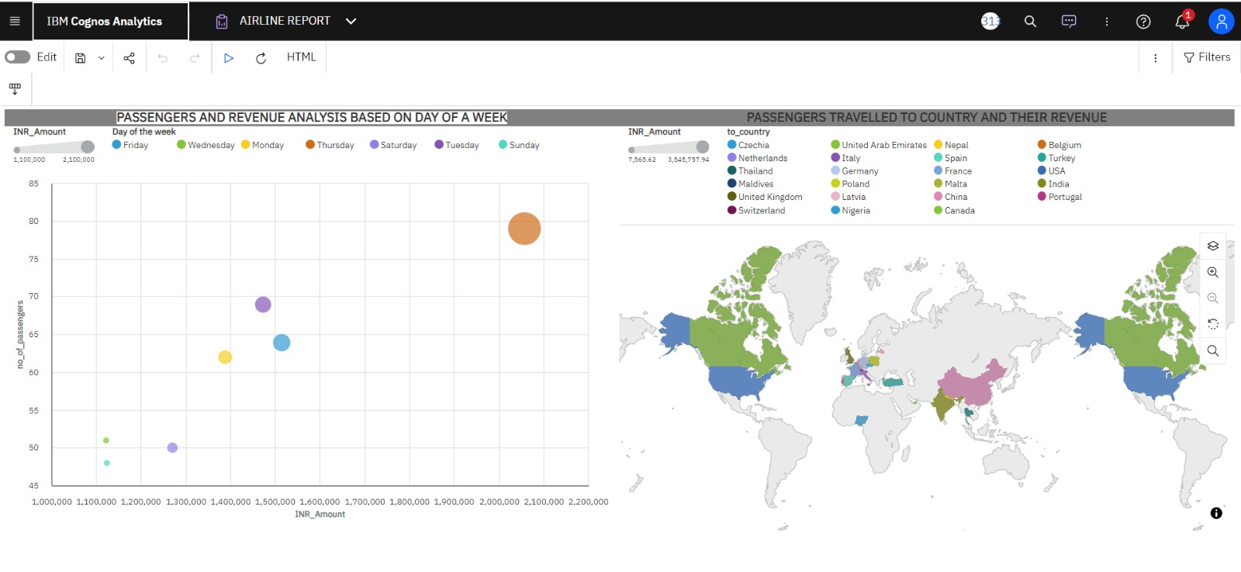

* **Performance Testing**

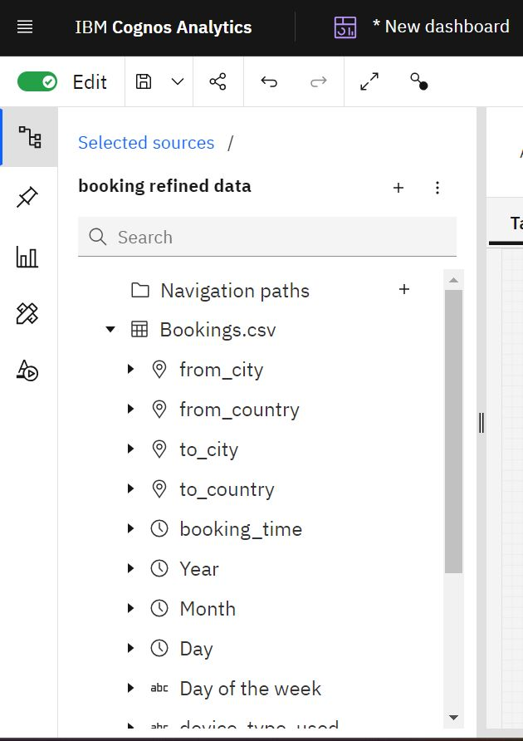

* **Web Integration**

Publishing helps us to track and monitor key performance metrics, to communicate results and progress. help a publisher stay informed, make better decisions, and communicate their performance to others.

